SpecterX Future Versions Log — Audit Logs

Future Version Record Notes
- Last Idea Added: Feb. 21st, 2026
- Current Product Record Reference: [Link or Version — if applicable]
- Current Platform Version Reference: Release Version 19

Current State
Ido Ben Tora has mapped out the current state. The missing events are marked in read and this can be viewed in Diagrams here. Our next step is to format for Excel.
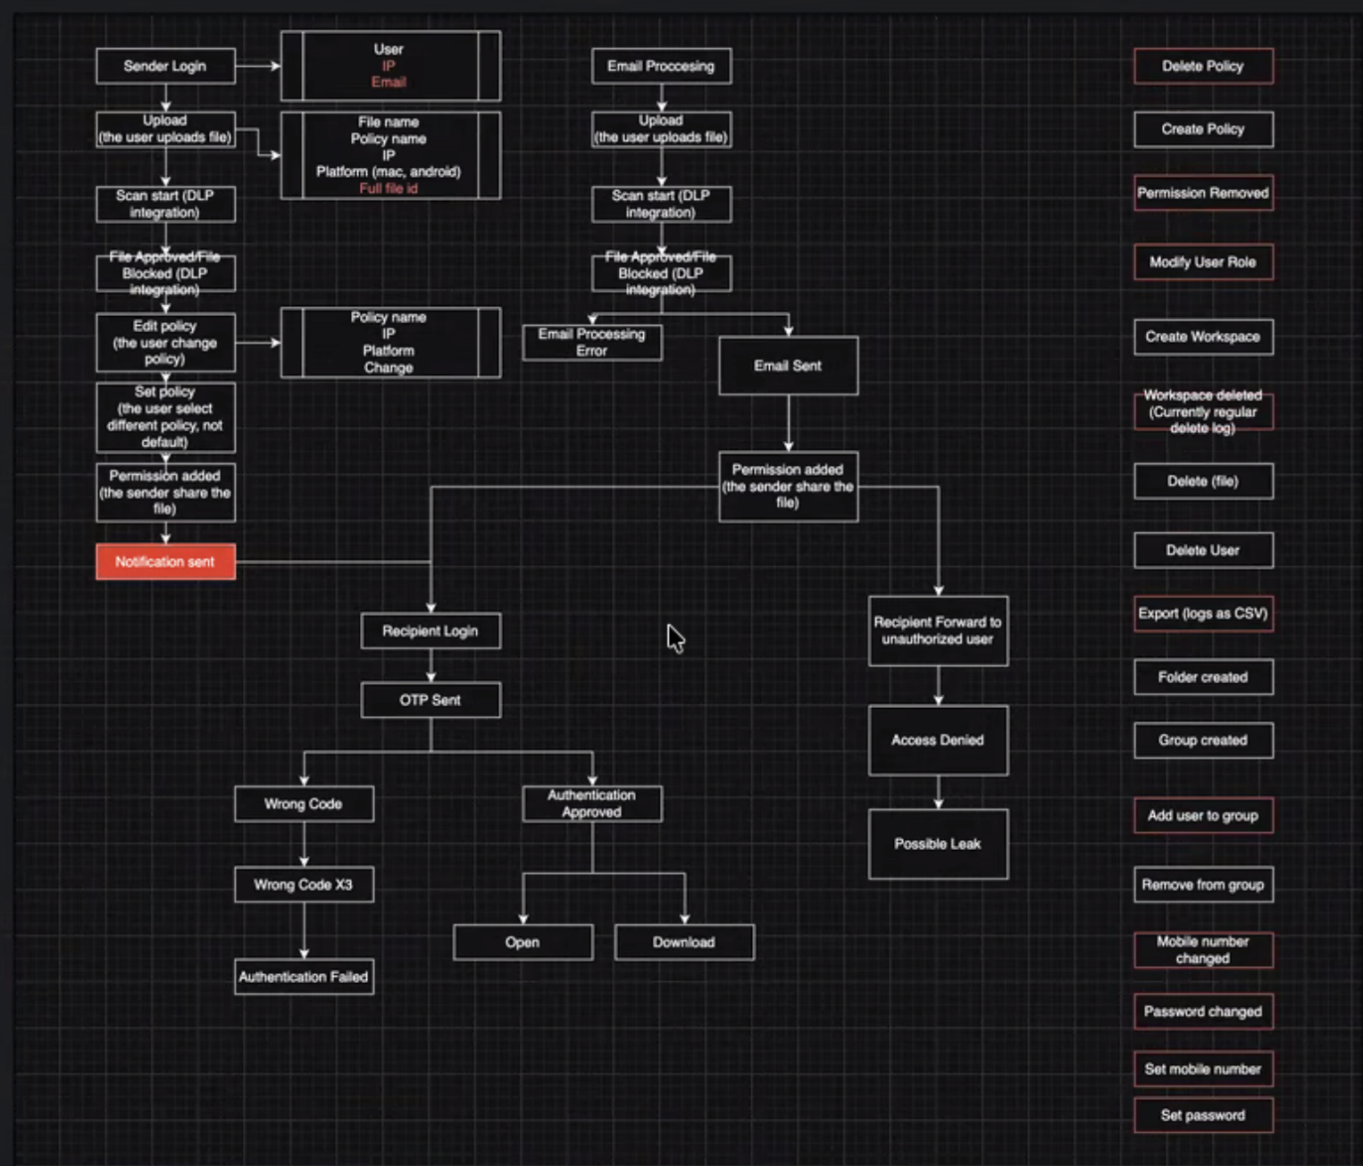

Strategic Direction — Likely Next Version (V2)

Failed to Download Events are Not Logged
- We are currently only logging successfully downloaded files and are not logging failed download events
  - Amitim raised this when they DNS server had reached it limit so all requests sent to the DNS got a timeout error and all users couldn’t download files

Provide Easier Comprehension of Audit Log Event
- Audit logs are a core asset of our product, but difficult to decipher with the current structure and language. Future versions of audit logs need to align audit detail and display to be user friendly both for admins and data owners.
- This is a known goal for audit log improvement which must remain as a primary goal when planning the future version states that include some or all of the initiatives addressed below.

Establish Separated Tenant Level Audit Logs for Admin Management
- Audit logs must expand to provide a tenant level audit log, accessible to tenant management teams such as support, security, and admin management. User level file logs would remain in the WebUI for file auditability for users, but the ability to view full audit logs at the file and tenant level would be built within the Admin Management Portal.
- Tenant Level Audit Logs would house:
  - Tenant access logs
  - Tenant governance configuration change logs for:
    - Policies
    - PAR
  - User onboarding & offboarding logs
  - Tenant integration configuration changes.
  - Tenant level errors

Improve Transparency of Retention Visibility in Audit Logs
- Audit logs evolve to support decoupling of file deletion and access retention as outlined by PRD planned retention changes.
  - Goals: allow transparent visibility to retention date expiration separating access from file deletion and explicit visibility to retention changes made either manually or through parent policy override.

Revise User Onboarding & File Ownership Logs with Upcoming Platform Changes
- The logic of user onboarding and file ownership is changing platform wide under this PRD and audit logs will need to support this.
- Scope involves audit changes:
  - To distinguish between file uploader via a recipient vs a data owner
  - To allow audit records to decipher how a collaborator license was onboarded

Group Individual audit log entrees by Events
- Currently, the audit log handles audit log entries as singular events that can be associated by individual file ID, log review of an entire folder, or grouped review of events within a Workspace.
- This leaves a current gap when associating multiple individual listed events that occurred together, such as summarizing collective results from Platform Governance Rules.
  - Today, all blocked files are listed as individual log actions when they are part of one share and do not provide a collective ID or log entree that associates these actions as occurring together.

Existing Logs will be enriched for with missing log events:
- Existing audit logs currently do not log all actions taken by the SpecterX system and recipients which create gaps in visibility of recipient engagement and issues for Support teams to understand and mitigate errors.
- Known missing logs events: (Jan.21st, 2025)
  - Link Opened Events
  - OTP Sent
  - SMS Transaction Logs from Courier
  - Email notification sent

